Installation and Setup of ESP32 on VAMAN Board in Ubuntu 24.04

STEP 1 Install ESP-IDF

→ sudo apt update
Install dependencies
→ sudo apt install git wget flex bison gperf python3 python3-pip python3-venv \
cmake ninja-build ccache libffi-dev libssl-dev dfu-util libusb-1.0-0
Clone ESP-IDF
→ cd ~

→ git clone --recursive https://github.com/espressif/esp-idf.git
Install tools
→ cd ~/esp-idf

→ ./install.sh esp32
Load environment
→ source ~/esp-idf/export.sh
Verify
→ idf.py --version
Expected output:
ESP-IDF v6.x.x

Verify the compiler
→ xtensa-esp32-elf-gcc --version
You should see something like:
xtensa-esp-elf-gcc (Espressif ...)

Load the ESP-IDF environment
Each new terminal requires:
→ cd ~/esp-idf
→ source export.sh
You should see output similar to:
Checking Python compatibility...
Adding ESP-IDF tools to PATH...
Done! You can now compile ESP-IDF projects.

Verify esptool
→ python3 -m esptool version
or
→ esptool.py version
Expected:
esptool.py v5.x.x

Verify Python
→ python3 --version

You already have:

Python 3.12.3

which is fully supported.

Check USB-UART Detection
Connect your USB-to-TTL adapter and run:
→lsusb

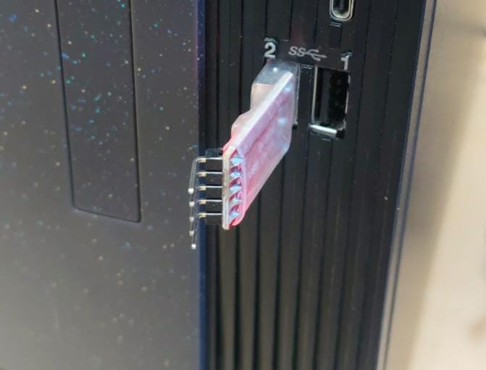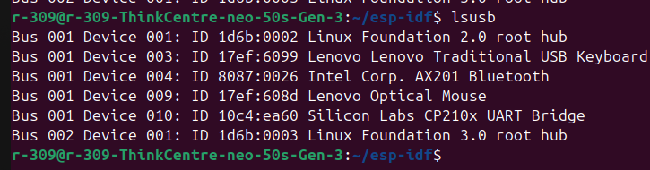

The device was detected as Silicon Labs CP210x UART Bridge

Check all serial devices
Instead of only checking ttyUSB*, run:
→ ls /dev/tty*
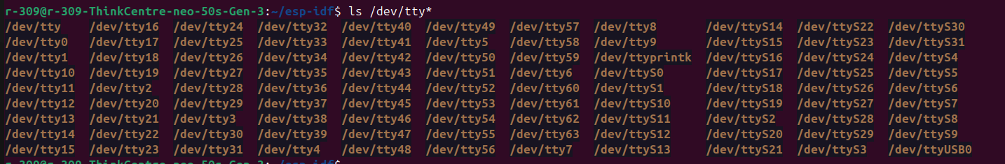

The /dev/ttyUSB0 is identified

Monitor the kernel while plugging in the adapter
Open one terminal and run:
sudo dmesg -w
Leave it running.
Now:
- Unplug the USB-to-TTL adapter.
- Wait 5 seconds.
- Plug it back in.
Copy the new lines that appear.
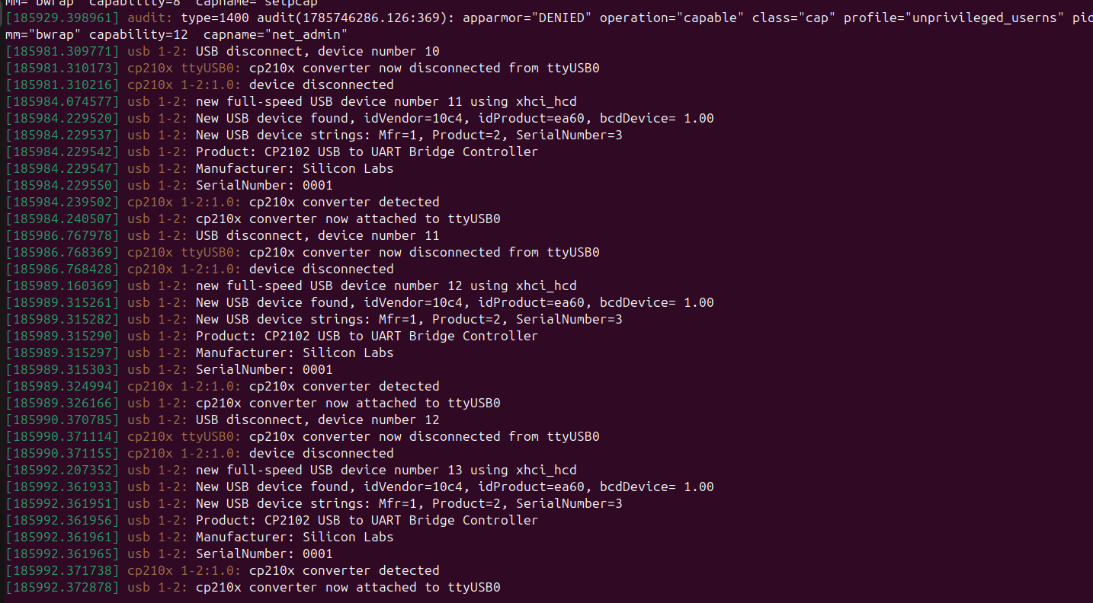
The cp210x is detecting by kernel
Go with the next commands
→lsmod | grep cp210x

→ls /dev/ttyUSB* /dev/ttyACM* 2>/dev/null

Which should detect the /dev/ttyUSB0

Now connect the UART USB TO VAMAN Board as follows
USB
│
▼
CP2102 USB-to-TTL
├── TX → ESP32 RX
├── RX → ESP32 TX
├── GND → ESP32 GND
├── 3.3V → ESP32 3.3V
└── GPIO0 → GND (only while flashing)
(press the USR buttorn to blink the green light which represents the flashing is started and then make sure the GPIO0 and GND are connected while flashing)

→ groups
→ esptool version
→ls -l /dev/ttyUSB0

Verify Communication with the ESP32
→ esptool --chip esp32 -p /dev/ttyUSB0 chip-id

The outputs of the above commands were as follows

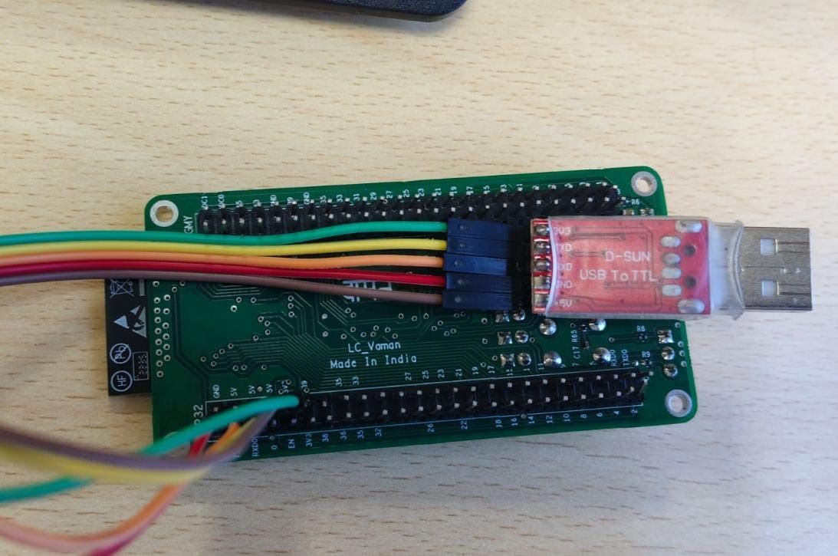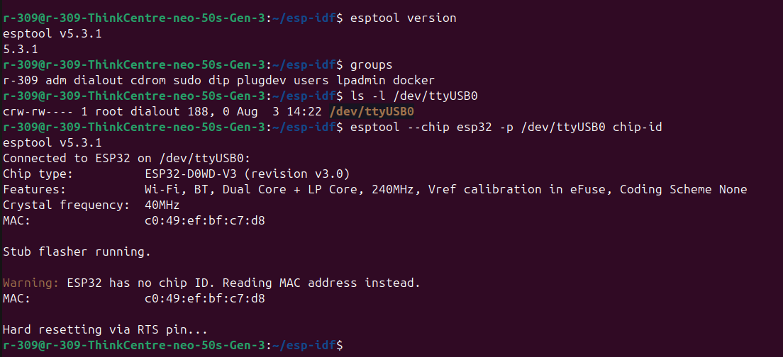

Now we will create a new ESP-IDF project folder for the 7-segment display instead of modifying the example folder.

We will do this from scratch.

Assumption:

VAMAN board = ESP32
ESP-IDF = working
Display = common anode 7-segment
We will directly control the 7 segments using ESP32 GPIOs.
No 7447 IC initially (direct GPIO test).
1. Go to ESP-IDF projects folder

Create a workspace:

→ cd ~/esp-idf
→ mkdir VAMAN_PROJECTS
→ cd VAMAN_PROJECTS
2. Create new 7-segment project

Use ESP-IDF example template:

→ idf.py create-project seven_segment_vaman

Enter folder:

→cd seven_segment_vaman

Check files:

→ ls

You should see:

CMakeLists.txt
main
3. Check main folder
→ cd main
→ls

You will see:

seven_segment_vaman.c
CMakeLists.txt

(or main.c depending on ESP-IDF version)

4. Open the C file

Example:

→ nano seven_segment_vaman.c

Delete everything and add this code by using CTRL+K.

ESP32 Common Anode 7-Segment Code

Connections:

Segment ESP32 GPIO
a GPIO16
b GPIO17
c GPIO18
d GPIO19
e GPIO21
f GPIO22
g GPIO23

Common anode:

Common pin → 3.3V
Segment ON = LOW
Segment OFF = HIGH

#include <stdio.h>
#include "freertos/FreeRTOS.h"
#include "freertos/task.h"
#include "driver/gpio.h"

#define SEG_A GPIO_NUM_16
#define SEG_B GPIO_NUM_17
#define SEG_C GPIO_NUM_18
#define SEG_D GPIO_NUM_19
#define SEG_E GPIO_NUM_21
#define SEG_F GPIO_NUM_22
#define SEG_G GPIO_NUM_23

int segments[7] = {
SEG_A,
SEG_B,
SEG_C,
SEG_D,
SEG_E,
SEG_F,
SEG_G
};

/*
Common Anode:
0 = ON
1 = OFF
*/

int digits[10][7] =
{
//a b c d e f g

{0,0,0,0,0,0,1}, //0
{1,0,0,1,1,1,1}, //1
{0,0,1,0,0,1,0}, //2
{0,0,0,0,1,1,0}, //3
{1,0,0,1,1,0,0}, //4
{0,1,0,0,1,0,0}, //5
{0,1,0,0,0,0,0}, //6
{0,0,0,1,1,1,1}, //7
{0,0,0,0,0,0,0}, //8
{0,0,0,0,1,0,0} //9
};

void display_digit(int num)
{

for(int i=0;i<7;i++)
{
gpio_set_level(
segments[i],
digits[num][i]
);
}

}

void app_main(void)
{

for(int i=0;i<7;i++)
{
gpio_reset_pin(segments[i]);

gpio_set_direction(
segments[i],
GPIO_MODE_OUTPUT
);
}

while(1)
{

for(int i=0;i<10;i++)
{

display_digit(i);

vTaskDelay(
1000 / portTICK_PERIOD_MS
);

}

}

}

Save:

CTRL + O
ENTER
CTRL + X
5. Configure ESP32 target

Go back:

→ cd ~/esp-idf/VAMAN_PROJECTS/seven_segment_vaman

Set target:

→ idf.py set-target esp32

6. Build

→ idf.py build

Successful message:
Project build complete.

7. Connect VAMAN

Check port:

→ ls /dev/ttyUSB*

Expected:

/dev/ttyUSB0

Verify Communication with the ESP32
→ esptool --chip esp32 -p /dev/ttyUSB0 chip-id
If error occurs once check if there are any loose connections and enter the virtual environment
By running
→. ~/esp-idf/export.sh
And then verify chip environment and make sure to keep GPI0 and GND in while flashing and green light should glow by pressing USR
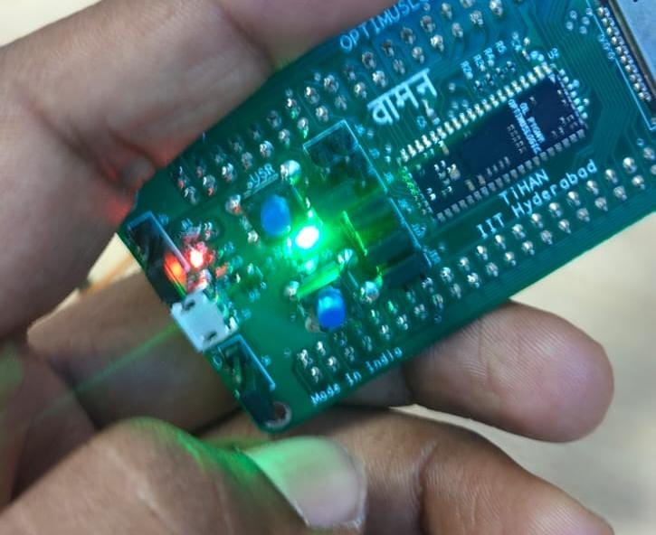

8. Flash seven segment firmware

→ idf.py -p /dev/ttyUSB0 flash
After flashing the output should be like as FOLLOWS
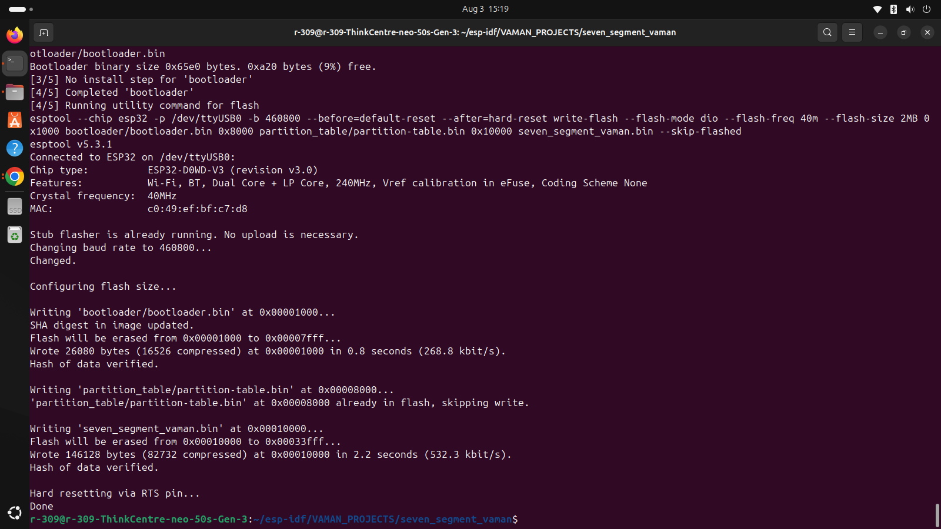

Press RESET.

The output of the current code is running of numbers 0→1→2→3→4→5→6→7→8→9→0

